Responsive

**DEADLINE:** 02/07/2019

## FOLDER STRUCTURE

|  |  |
| --- | --- |
| FL11_HW5/*     └─ task/**      └─ FL11_HW5.docx**      └─ examples/**  └─ desktop.png**  └─ hover-effects.png**  └─ mobile.png**  └─ tablet.png**  └─ homework/*     └─ img/*      └─ news1.jpg *  └─ news2.jpg *  └─ post1.jpg *  └─ post2.jpg *  └─ post3.jpg *  └─ post4.jpg *     └─ css/*  └─ styles.css*  └─ index.html* | * - required  ** - restricted (no need to submit) |

## TASK

In this homework, you should create a web page and provide styles for specific screen resolutions as shown in the pictures (pixel perfect is not required):

* *examples/desktop.png* - shows how the page should look like on the large screen
* *examples/tablet.png* - shows how the page should look like on the tablet
* *examples/mobile.png* - shows how the page should look like on the phone screen

All colors already declared in the FL11_HW5/homework/css/styles.css file.

Please follow this requirements during your work:

* The @media query breakpoints that are used in the example (desktop first) should be:
  + max-width: 1400px (for the desktop)
  + max-width: 768px (for the tablet)
  + max-width: 480px (for the phone screen)

* the even post elements should have description on the left and preview image on the right hand and the odd ones should have description on the right and preview image on the left hand as shown in **Figure 1**:

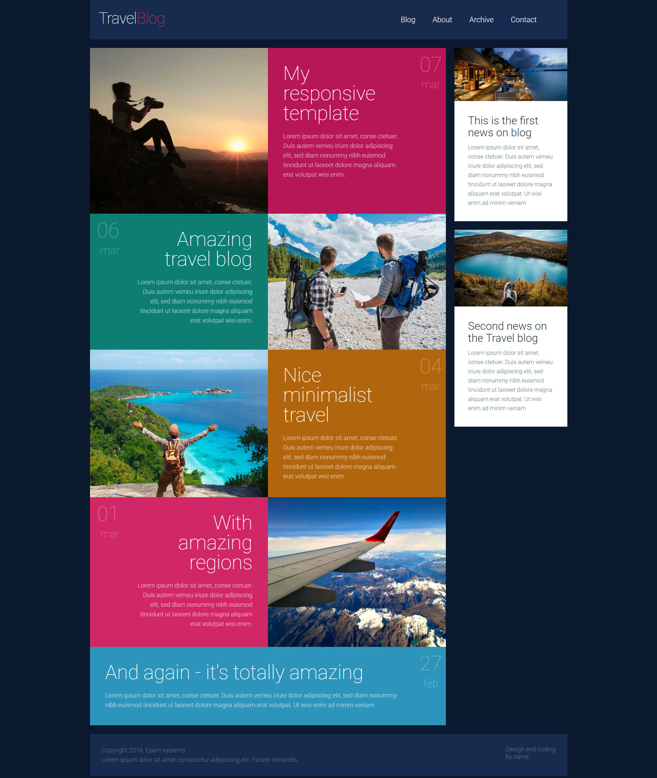

**Figure 1 - post elements**

Please use appropriate pseudo-class to place elements left to right or vice versa.

In case we need to add a new post, then the last added item should be shown reversed regarding the previous one

* menu items and post elements should have animated hover effects as shown in **image 2**:

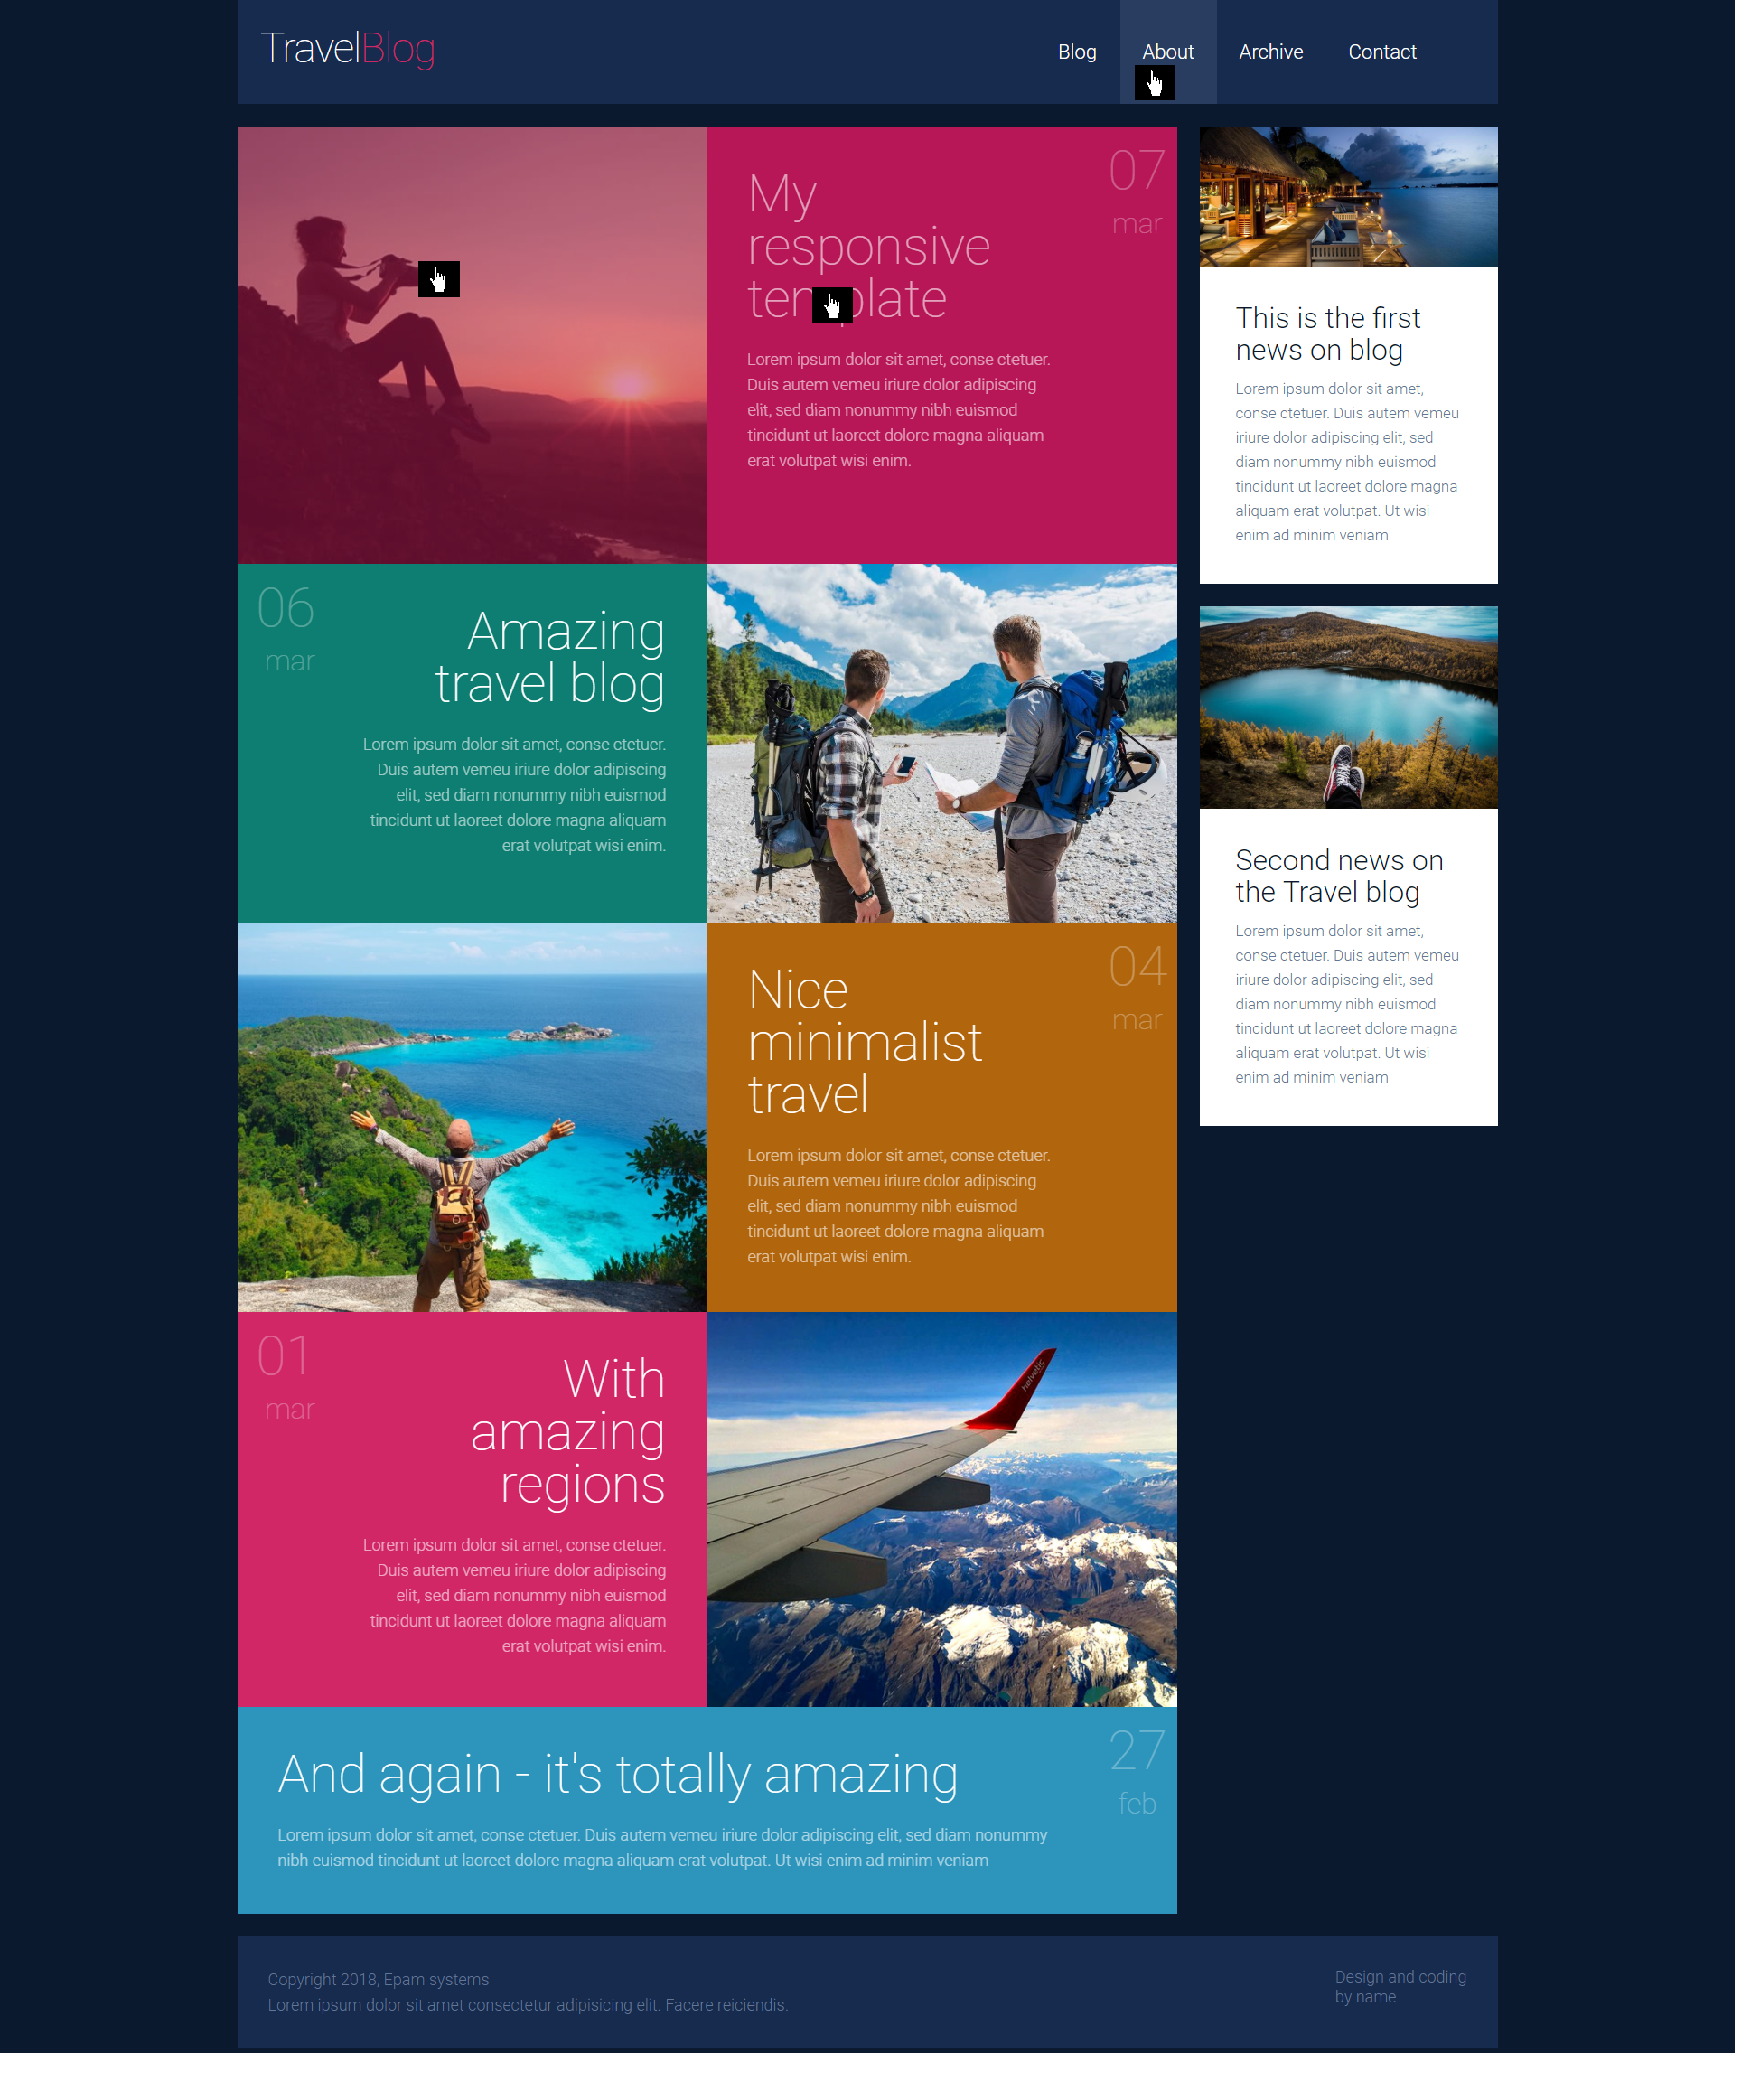

**Figure 2 - menu items and post elements hover effects**

* the sandwich button which appears in tablet and phone mode shouldn’t do anything, just replace the menu from desktop view (**image 3**):



to

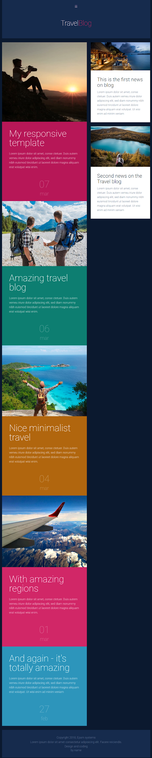

**Figure 3 - menu transformation**

* you can use mobile first or desktop first approach. It’s up to you;
* You could format existing code in styles.css file if needed.

## RESTRICTIONS

* Please use pure CSS only, without any preprocessors;
* Don’t use any 3rd party tools or libs (e.g. Bootstrap);
* Use only styles.css file for your CSS code without splitting it;
* Usage of **JavaScript** is forbidden;
* Adding **task/** and **examples/** folders is forbidden. Do not push it to repository (only homework/ folder should be pushed);
* No requirements for browser support (should work properly in Google Chrome last version).

## BEFORE SUBMIT

* Verify that all functionality is implemented according to requirements;
* Format your code (remove redundant spaces, lines of code etc.);
* Add only related to your code, valid comments;
* Validate in <https://validator.w3.org/> and <https://jigsaw.w3.org/css-validator/> ;
* Make sure your GitHub folder structure meets the required one (without **task** and **examples** folders)

## SUBMIT

* The **FL11_HW5** folder should be uploaded to GitHub repository **“FL-11”** into **master** branch

## USEFUL LINKS

* <https://developer.mozilla.org/en-US/docs/Web/CSS/position>
* <https://developer.mozilla.org/en-US/docs/Web/CSS/@media>
* <https://developer.mozilla.org/en-US/docs/Web/CSS/var>
* <https://css-tricks.com/snippets/css/a-guide-to-flexbox/>
* <https://css-tricks.com/snippets/css/complete-guide-grid/>